**SeraCult Collection Instructions**

To obtain the most accurate test results, please observe the following dietary recommendations, beginning two days prior to collecting the first stool sample. Continue to observe these restrictions until you have completed all three slides.

You may consume: Do not consume:

Cooked and uncooked vegetables rare and lightly cooked meats

Moderate amount of high fiber foods, like Cauliflower, horseradish, red radishes, turnips, broccoli and bran, cereal and peanuts cantaloupe

Plenty of fruits such as plums, grapes and apples Iron rich supplements

Well cooked pork, poultry and fish Aspirin and other medications which may cause gastrointestinal irritation

Vitamin C in excess of 250 mg per day

**Important: Consult your physician before restricting ANY prescription medication.** If there are any problems with any of the above dietary items, talk to your doctor.

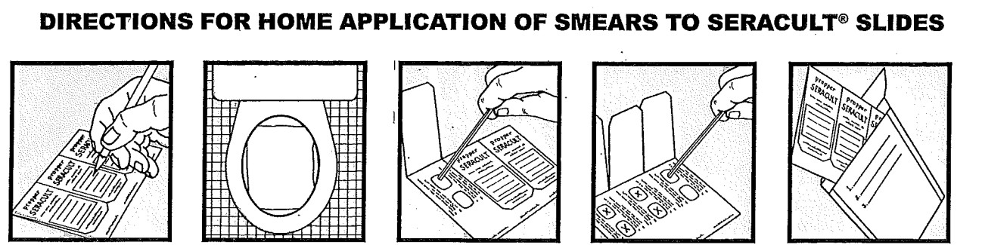

1. Write your name, address, age and telephone number on the front flap of all 3 slides.

2. When you are ready to collect a fecal specimen, place a piece of plastic wrap across the toilet under the seat, allowing stool to fall onto the plastic wrap.

3. Open the front flap of the first slide (The side with your name on it), you will see 2 windows. Collect a

small stool sample on the end of the applicator stick and apply a THIN smear to one window of the slide. Use the same stick to collect another sample from a different part of the stool and apply it to the other window. Remove plastic wrap (do not flush) and flush specimen. Discard the applicator stick in the trash. DO NOT apply specimen to the back side of the card. This flap is for lab use only.

4. **If you are only required to collect 1 card/specimen, you are finished. Please return specimen to the lab.**

5. Repeat this procedure for the next two bowel movements using the second and third slides and applicators. Remember to enter the collection date on each slide.

6. Note: Specimen collection should NOT be attempted during menstrual period or hemorrhoidal bleeding.

7. When you have completed the third bowel movement collection, place all 3 slides in the plastic bag, with your order from the office, and return to the nearest Christian Hospital or Alton Memorial laboratory draw site.